**Laboratory Activity No. 2:**

**Topic belongs to**: **Software Design and Database Systems**

**Title**: *Designing the Database Schema for the Library Management System*

**Introduction**: In this activity, you will design the database schema for the Library Management System. The database will include tables for books, authors, users, and borrowing records. You will also learn how to use Django’s ORM (Object-Relational Mapping) to define the models.

Results: By the end of this activity, you will have successfully defined the database schema using Django models, created the corresponding database tables, and registered the models in the admin panel. (print screen the result and provide the github link of your work)

Github Link: https://github.com/Caye17

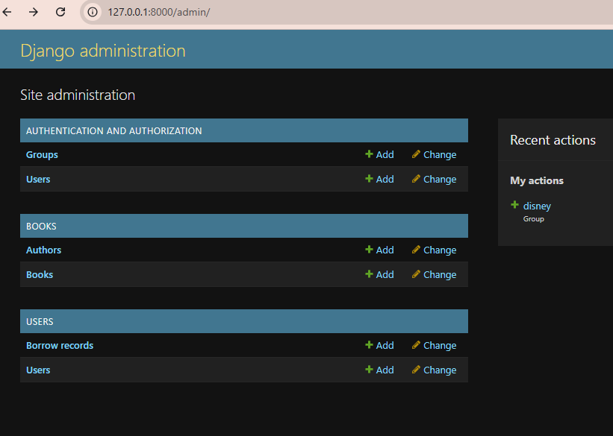

**Follow-Up Questions**

What is the purpose of using ForeignKey in Django models?

ForeignKey establishes a relationship between two models, enabling data association and enforcing referential integrity.

**How does Django’s ORM simplify database interaction?**

Django’s ORM eliminates the need for writing raw SQL queries by allowing developers to interact with the database using Python objects.

**Findings**

The Django ORM makes database management more efficient by abstracting SQL queries.

The Library Management System can easily manage book borrowing records using relational models.

**Summary**

This activity involved designing a Library Management System using Django’s ORM. The database schema was defined, models were created, and migrations were applied to generate database tables. The Django admin panel was also configured to manage data.

**Conclusion**

By following this laboratory activity, you have successfully:

Designed and implemented a relational database schema using Django.

Created Django models to manage books, authors, users, and borrowing records.

Used Django’s ORM to simplify database interactions.

This knowledge is essential for building robust web applications that rely on structured data storage and retrieval.